<<20130422>> Archived distributions can be retrieved at; <<http://tinyurl.com/azg3eyl> <<http://tinyurl.com/azg3eyl>> >. This archive includes a html version of this list distribution and its MS/WORD version with its filename as “year-month-date.doc.” You can also access all of its attachments, if any.  
  
Youcef Oubraham <<Youcef.oubraham@stevens.edu>>  
  
Michael Scalero <<mscalero@stevens.edu>>  
  
Prof. Victor B. Lawrence <<Victor.Lawrence@stevens.edu>>  
  
Chief (Sir) Charles Ugo Eke <<bychief@yahoo.com>>  
  
P. Tapio Varis, Ph.D., Professor <<tapio.varis@uta.fi>>   
  
Ms. Dorothy K. Gordon <<dorothyg@aiti-kace.com.gh>>  
  
Hans Rudolf Herren, Ph.D. <<hh@millennium-institute.org>>   
  
Prof. Muhammadou M. O. Kah <<mkah@utg.edu.gm>>   
  
Mr. Michael C. Attipoe <<mcattipoe@hotmail.com>>   
  
Francisco Bozzano‑Barnes <<francisco@tenureecology.com>>  
  
**References:**

(a) Press Release: “Stevens to Host Public Videoconference on New West African Broadband Internet Initiatives”  
<<http://www.stevens.edu/news/content/stevens-host-public-videoconference-new-west-african-broadband-internet-initiatives>>  
  
(b) Agenda of “Public Seminar on African Broadband Internet and Early Warning System Launch,” which is to be held at the Stevens Institute of Technology on April 18th  
<<http://tinyurl.com/cylach6>>

View the Blackboard Collaborate recording  
<<https://sas.elluminate.com/site/external/jwsdetect/playback.jnlp?psid=2013-04-18.0639.M.03E3D7E337890D94998E11A7F9C3D0.vcr&sid=2012174>>  
  
NOTE: You have to have the latest JAVA before downloading this recording file.

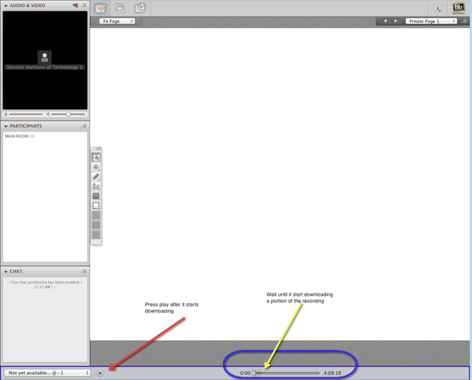

(c) Chapter 2 of Draft of of Proposed Book; "Electronic Global University System and Services"  
<<http://tinyurl.com/6r8c63>>  
  
(d) Recording video of 1994 and 1996 Global Lecture Hall (GLH) videoconferencings  
<<http://tinyurl.com/7te8mxh>>  
  
(e) Tapio Varis; Slide presentation, “ICT and the Culture of Peace”  
<<http://tinyurl.com/cfunwyu>>

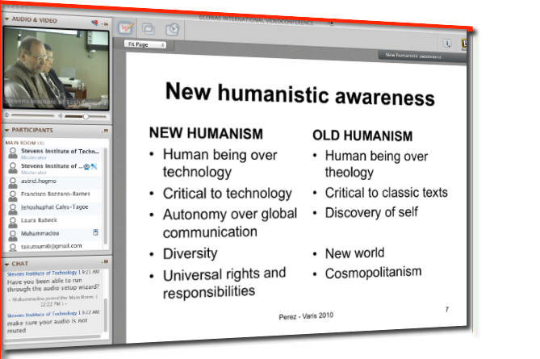  
<<http://tinyurl.com/ccedond>>  
  
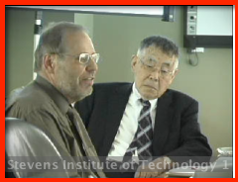  
<<http://tinyurl.com/d5nfjkg>>  
  
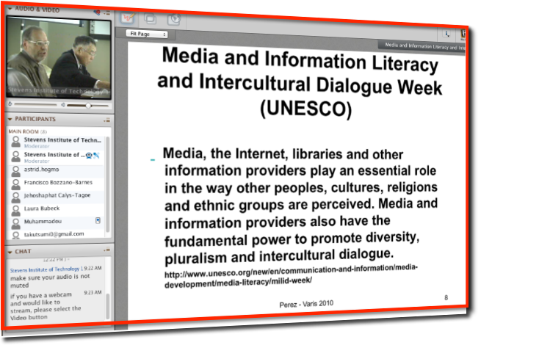  
<<http://tinyurl.com/ce3bek5>>  
  
**Dear Youcef:**Many thanks for those screen-shots.

(f) Victor Lawrence; Slide presentation, “Technology for the Other 3-4 Billion Inhabitants”  
<<http://tinyurl.com/cxxq8dk>>  
  
(g) Hans R. Herren; Slide presentation, “System Dynamic Modeling”  
<<http://tinyurl.com/cyeb7x2>>  
  
(h) T. Utsumi; Slide presentation, “African Broadband Internet and Early Warning System Launch”  
<<http://tinyurl.com/d3feja5>>  
  
(i) List of Webcam Logged-­in Parties  
<<http://tinyurl.com/cchqcs4>>  
  
(j) Log of Chatting; Blackboard Collaborator webcam  
<<http://tinyurl.com/d7lhjcm>>

**Dorothy, Hans, Muhammadou, Charles, and Mike Attipoe:**Pls retrieve this to respond to queries addressed to you in this log.

(k) Contact Information of ECOWAS Participants in GLH videoconferencing at Stevens Institute of Technology, April 18, 2013 (9:00 am to 12:30 pm), (Revised version: April 9, 2013)  
<<http://tinyurl.com/dy56ouw>>  
  
(l) The Global Early Warning System (GEWS) with The Global University System (GUS): Their Use Within ECOWAS Countries; A Priority Agenda Item of the First GEWS/GUS Planning Workshop at School of International and Public Affairs (SIPA), Columbia University, and The Stevens Institute of Technology (August 2, 2012)  
<<http://tinyurl.com/bmo9ljj>>  
  
(m) The Global Early Warning System (GEWS) with The Global University System (GUS): Their Use Within ECOWAS Countries (October 7, 2012)  
<<http://tinyurl.com/bqbjh9g>>

**Dear Youcef:**  
(1) Many thanks for your msg (**ATTACHMENT I** below) and the recording file of the session of our “Global Lecture Hall (GLH)”/ECOWAS videoconferencing held at your Stevens Institute of Technology on April 18th (References (a) and (b) above).  
  
**Dear Victor, Mike, Youcef and others at the Stevens:**  
(2) I would like to express my sincere thanks for the tremendous success of our event. Such a success would not happen without extraordinary cooperation and help from your people.  
  
(3) Previously I have done many GLH multipoint-to-multipoint, multimedia interactive videoconferencing once or twice every year in the 1990s — using satellites, sometime 11 channels on 9 transponders, spanning the globe from Moscow to New Zealand and connecting many universities between them.  However, they were mostly one-way broadcasting talking heads-type, and very expensive and cumbersome to arrange necessary connections around the world.  
  
Now I am very happy to find out that the Blackboard Collaborate webcam <www.stevens.edu/ecowas> did not need any extra telecom expenses, and yet had very clear images and voices.  Also, it provided us with interactive dialogues from many locations — without any need for extra studio nor dish antenna, etc.  
  
**Dear Charles:**  
(4) Many, many thanks for your setting up an audio conference site at free of charge, since those people who could not access to the event’s official Blackboard Collaborator webcam through Internet could come in through the Plain Old Telephone Service (POTS) to this site.  
  
(5) For example, Dorothy Gordon of Ghana did successfully came in to the webcam during our rehearsal on 4/16th, but not during the 4/18th event.  The phone system of the Stevens did not allow to make an oversea phone call, and Dorothy refused to make her call into the audio conference site due to its high telephone cost.  I then called her from my iPhone (*) which was casted over the speaker phone which was connected to the audio conference site — this speaker phone was placed next to the microphone which went into the webcam.

(*) because I knew that the calling overseas from the US is cheaper than other-way round thanks to the invention of the telephone made by Graham Bell in 1876.  
  
**Dear Youcef, Mike and Paco:**The lessen here is that it is absolute necessity to have a backup — especially for the major event like this.  A son of Nikita Khrushchev, former Prime Minister of the Soviet Union, was at the Dartmouth College in Massachusetts and arranged a satellite linkage between the college and some unit in Moscow.  Our 1994 GLH (Reference (d) above) at the University of Tennessee in Knoxville (UTK) was supposed to utilize this satellite linkage to reach an international distance learning conference in Moscow, but could not due to a technical glitch of the satellite.  We then used ShareVision through POTS very successfully.  Greg Cole also demonstrated the use of MOSAIC which was the predecessor to NETSCAPE, the first commercial web browser.  Greg then kindly says that this event initiated his GLORIAD, which is now almost US$280 million set-up.

**Dear Tapio (Reference (e) above), Victor (Reference (f) above) and Hans (Reference (g) above):**  
(6) I express my sincere thanks for your excellent presentations.  Hans, as you see in the recording of the session in the Reference (b) above, your image and voice came very clearly, though you accessed to the Blackboard Collaborator webcam through ordinary Internet available at your hotel room in Addis Ababa, Ethiopia.  
  
**Dear Tom (Atlanta, GA) and Edwin (Germany):**  
(7) Many, many thanks for your participations with valuable suggestions and comments for our GEWS/GUS projects.  
  
Your voice came very clearly.  
  
**Dear Dorothy (Ghana):**  
(8) Sorry you could not come in through the webcam, though you had a successful rehearsal a few days ago.  
  
Pls retrieve the Reference (j) above to find out whom your questions were addressed to follow-up with the addressees.  
  
**Dear Muhammadou (Gambia):**  
(9) Your image and voice were very clear — probably thanks to your connection to the “Africa Coast to Europe (ACE)” ultra high speed (5 tera bps) optical fiber submarine cable of Baharicom Development Company.  
  
I greatly appreciated to hear of your strong willingness to work on our GEWS project — even offering your university for the workshop for ECOWAS countries.  
  
**Dear Everybody:**  
(10) It was really significant historical event — as I said during my presentation, this April 18th event for the GEWS/ECOWAS project may become the initiation of constructing the “Electronic United Nations”!! Let’s work together!!



Best, Tak

**ATTACHMENT I**

**From:** Youcef Oubraham <<y1oubrah@stevens.edu>>  
**Subject: Re: Inquir**y  
**Date:** April 21, 2013 11:22:56 AM EDT  
**To:** Tak Utsumi <<takutsumi0@gmail.com>>, Victor Lawrence <<victor.lawrence@gmail.com>>, Mool Singhi <<msinghi@baharicom.net>>, Ali Mostashari <<ali.mostashari@gmail.com>>, Rob Harari <<robert.harari@stevens.edu>>, Charles Ugo Eke <<bychief@yahoo.com>>, "Dorothy K. Gordon" <<director-general@aiti-kace.com.gh>>, Thomas Mensah <<gaaerosp55@aol.com>>, Solomon Peter Gbanie <<S.Gbanie@adfa.edu.au>>, Greg Cole <<gcole@gloriad.org>>, Daniel Dalohoun <<dndalohoun@hotmail.com>>, "Muhammadou M. O. Kah" <<mkah@utg.edu.gm>>, Hervé Lohoues <<hlohoues@hotmail.com>>, Jinnah Momoh <<jsmomoh2000@yahoo.ca>>, Michael Attipoe <<mcattipoe@hotmail.com>>, Susie Baker <<sbaker@gloriad.org>>, Hans R Herren <<hh@millennium-institute.org>>, Jonas A S Redwood-Sawyerr <<abiosehrs@gmail.com>>, Francisco Bozzano-Barnes <<paco.bozzano@gmail.com>>, Mohamed Alie Bah <<malie.bah@gmail.com>>, Anita Colliatie <<anita@gloriad.org>>, Kim Summerfield <<kim@gloriad.org>>, "<dashaeusle@t-online.de>" <<dashaeusle@t-online.de>>, Alpha Sesay <<alphaabasssesay@yahoo.com>>, Lamin Camara <<lamincamara11@yahoo.com>>  
**Cc:** Michael Scalero <<mscalero@stevens.edu>>, Youcef Oubraham <<youcef.oubraham@stevens.edu>>  
  
To All,  
  
I am pleased to let you know that the recoding of the event is now available.  
Press on the link below to view the recording of the event on April 18, 2013:  
  
View the Blackboard Collaborate recording  
<<https://sas.elluminate.com/site/external/jwsdetect/playback.jnlp?psid=2013-04-18.0639.M.03E3D7E337890D94998E11A7F9C3D0.vcr&sid=2012174>>  
  
I have attached a screenshot of the recording interface. As described please wait until it starts downloading then press play.  
Later we can try to edit it if that is what is needed.  
  
Mike an I were very please to work with all of you. It was a wonderful experience.  
  
Thank You.  
  
Youcef  
  
 **_______________________________**_  
**Youcef Oubraha**m  
E-Learning Technologies Administrator  
Library Systems Administrator  
Information Technology Department  
Stevens Institute of Technology  
Castle Point on Hudson  
Hoboken, NJ 07030  
Phone: 201-216-5418  
<Youcef.oubraham@stevens.edu>

From: Tak Utsumi <<takutsumi0@gmail.co>m>  
Date: Sunday, April 21, 2013 10:09 AM  
To: Youcef Oubraham <<y1oubrah@stevens.ed>u>, Michael Scalero <<mscalero@stevens.ed>u>, Victor Lawrence <<victor.lawrence@gmail.co>m>, Mool Singhi <<msinghi@Baharicom.Ne>t>, Ali Mostashari <<ali.mostashari@gmail.co>m>, Rob Harari <<robert.harari@stevens.ed>u>, Charles Ugo Eke <<bychief@yahoo.co>m>  
Cc: Tak Utsumi <<takutsumi0@gmail.co>m>, Fransisco Bozzano-Barnes <<paco.bozzano@gmail.co>m>, Greg Cole <<gcole@gloriad.or>g>, Daniel Dalohoun <<dndalohoun@hotmail.co>m>, "Muhammadou M. O. Kah Muhammado M. O. Kah Muhammadou M. O. Kah" <<mkah@utg.edu.g>m>, "<director-general@aiti-kace.com.g>h" <<director-general@aiti-kace.com.g>h>, Herve Lohoues <<hlohoues@hotmail.co>m>, Solomon Peter Gbanie <<S.Gbanie@adfa.edu.a>u>, Thomas Mensah <<gaaerosp55@aol.co>m>, Hans R Herren <<hh@millennium-institute.or>g>, Jinnah Momoh <<jsmomoh2000@yahoo.c>a>, Lamin Camara <<lamincamara11@yahoo.co>m>, Michael C Attipoe <<mcattipoe@hotmail.co>m>, Jonas A S Redwood-sawyerr <<abiosehrs@gmail.co>m>, Alpha Sesay <<alphaabasssesay@yahoo.co>m>, Mohamed Alie Bah <<malie.bah@gmail.co>m>, Susie Baker <<sbaker@gloriad.or>g>, Kim Summerfield <<kim@gloriad.or>g>, Anita Colliatie <<anita@gloriad.or>g>, "<dashaeusle@t-online.d>e" <<dashaeusle@t-online.d>e>  
Subject: Inquiry  
  
Dear Youcef and Mike:  
  
(1) I wonder why Dorothy Gordon of Ghana could not come in your webcam on 4/18th, though she could do so during our rehearsal on 4/16th.  
  
(2) Hans’ msg (ATTACHMENT I below) says that his connection was made through ordinary Internet at his hotel room in Addis Ababa, Ethiopia.  As you recall, his image and audio were very clear, as similar to Muhammadou”s from Gambia whose line was connected to the broadband Internet of the “Africa Coast to Europe (ACE)” ultra high-speed optical fiber submarine cable along the west coast of African continent.  
  
(3) I would then think that we would better try a similar connection with our colleagues in Sierra Leon, Benin and Nigeria, though the latter two are not connected to the ACE yet (Nigeria is to be connected in this coming July and Benin by the end of this year) — we did not have the participation of those three at the 4/18th event.   
  
Can your facility provide us with such test? -- I would like to do this test prior to our planning workshop of our GEWS project at the office of GLORIAD at the University of Tennessee in Knoxville (UTK), since I would like to do a similar webcam videoconferencing during this workshop, too.  Greg Cole of GLORIAD is finishing up his very urgent task by the end of this week and then work on his submission of our grant application to the NSF for this workshop at his office — hopefully in this coming summer.  
  
Best, Tak

ATTACHMENT I  
  
  
From: Hans R Herren <<hh@millennium-institute.org>>  
Subject: Re: Sincere thanks  
Date: April 21, 2013 4:44:05 AM EDT  
To: Tak Utsumi <<takutsumi0@gmail.com>>  
Cc: "<dashaeusle@t-online.de>" <<dashaeusle@t-online.de>>, Francisco Bozzano-Barnes <<paco.bozzano@gmail.com>>  
  
Dear Tak,  
  
No problem and thanks. Was a pleasure to tune in for the conference….sorry that I was late, the problem first was that I did not have Java downloaded, although I thought that I had it!  
  
Also, I was using the hotel internet access….so I guess it was pretty good…..I was impressed by the quality of the images and sound from your end too. The Blackboard Collaborate is a very good way to have such conf calls…….and I shall try to use it too for our internal meetings and also Board meetings…to lower our carbon footprint!  
  
Thanks to Francisco for the facilities, really a great set up.  
  
Best, Hans  
  
  
  
  
On Apr 21, 2013, at 12:49 AM, Tak Utsumi <<takutsumi0@gmail.co>m> wrote:  
  
Dear Claudia:  
  
(1) Very sorry I confused as sending my msg to Hans to you — see below.  
  
(2) Anyway, I greatly appreciated to meet with you after so long time.  
  
Hope you enjoyed attending Tapio’s seminar at the Columbia U. and our GLH/ECOWAS  videoconferencing at the Stevens.  
  
Dear Hans:  
  
(3) Sorry, I made a mistake as sending my msg to you to Claudia in my previous distribution.  
  
On 4/20/13 5:41 PM, "Tak Utsumi" <<takutsumi0@gmail.c>om> wrote:  
  
Dear Hans:  
  
(1) Many, many thanks for your participation in our GLH/ECOWAS videoconferencing at the Stevens on 4/18th.  
  
Participants here at the Stevens were all very much impressed with your talk.  Congratulations!!  
  
(2) Your voice and image came through very clearly — Youcef will put the recorded session into the Stevens web so that you will be able to review it.  
  
I would like to know what the speed of your Internet access in Ethiopia — was that from your hotel room or in an office at a university?  
  
Best, Tak

**List of Distribution**

Youcef Oubraham  
E-Learning Technologies Administrator  
Library Systems Administrator  
Information Technology  
Stevens Institute of Technology  
Castle Point on Hudson  
Hoboken, NJ 07030  
Phone: 201-216-5418  
<Youcef.oubraham@stevens.edu>  
  
Michael Scalero  
E-Learning Technology Manager  
Information Technology  
Stevens Institute of Technology  
The Innovation University  
Castle Point on Hudson  
Hoboken, NJ 07030  
201-216-5475  
Cel: 201-805-7551  
Fax: 201-216-8960  
<mscalero@stevens.edu>  
www.twitter.com/mscalero  
www.stevens.edu  
  
Prof. Victor B. Lawrence  
Associate Dean: Special Topics  
Batchelor Chair Professor of Electrical Engineering  
Department of Electrical & Computer Engineering  
Burchard Building, Room 205  
Stevens Institute of Technology  
Castle Point on Hudson  
Hoboken, NJ 07030  
Ph.: 201 216-5636  
Cel: 732-407-9500  
Fax.: 201 216-8246  
<Victor.Lawrence@stevens.edu>  
<http://www.ece.stevens-tech.edu/iNetS/people/LawrenceVita.html> -- brief bio  
<http://www.stevens.edu>  
  
Chief (Sir) Charles Ugo Eke  
Founder/CEO  
Infotechs Systems, LLC  
312 Washington Str.  
P. O. Box 22635  
Newark, NJ 07102  
908-405-7441  
Fax: 973-242-4070  
<bychief@yahoo.com>  
www.infotexsystems.com  
  
P. Tapio Varis, Ph.D., Professor  
Acting President, Global University System  
UNESCO Chair in Global e-Learning with applications to multiple domains  
Professor and Chair of Media Education  
Research Center for Vocational Education & Hypermedia Laboratory  
University of Tampere  
P.O.Box 229  
FIN-13101 Hameenlinna  
FINLAND  
+358-3-3551-3608  
Tel: +358-3-614-5608--office in Hameenlinna  
Tel: +358-3-215 6243--mass media lab in Tampere  
GSM: +358-50-567-9833  
Fax: +358-3-614-5611 or +358-3-3551-3611  
<tapio.varis@uta.fi>   
<tapio.varis@hamk.fi>   
<tapio.varis@helsinki.fi>   
<http://www.uta.fi/~titava>   
www.ecml-eu.org -- about ECML project.  
<http://www.uta.fi/conference/mediaskills/>  
  
Ms. Dorothy K. Gordon  
Director-General  
Advanced Information Technology Institute (AITI)  
Ghana-India Kofi Annan Center of Excellence in ICT  
2nd Avenue, Opp. Council of State  
PMB, State house  
Accra, Ghana  
Tel: 233-21-679-542 to 5  
     233-21-683-579 (direct)  
Cel: 23-244-311-348  
Mobile: 233 265005712  
Fax: 233-21-679-549  
<jhdorothyg2003@yahoo.com>  
<dorothyg@aiti-kace.com.gh>  
<director-general@aiti-kace.com.gh>  
www.aiti-kace.com.gh  
www.aiti-kace.com  
<http://www.aiti-kace.com.gh/index.php?option=com_content&amp;task=view&amp;id=106&amp;Itemid=93>  
<http://www.kaiptc.org/home/>  
  
Hans Rudolf Herren, Ph.D.  
President  
Millennium Institute  
1634 I St NW, Suite 300  
Washington, DC 20006  
cell + 1 530 867 4569   
Tel  202 383 6200   
Fax 202 383 6209  
<hansrherren@mac.com>   
<hh@millennium-institute.org>   
www.millennium-institute.org  
www.nourish9billion.org   
<http://www.biovision.ch/nc/en/home/>   
www.threshold21.com  
<http://www.biovision.ch>   
<http://www.eduvision.or.ke>   
<http://www.millenniuminstitute.net/>   
  
Prof. Muhammadou M. O. Kah  
Vice Chancellor  
University of The Gambia  
MDI Road, Kanifing South  
Banjul area  
The Gambia, West Africa  
Tel: 4372213 (Main switchboard)  
Cell: +220 336 1010  
Fax: 4395064  
Skype: prof.Kah  
<mkah@utg.edu.gm>   
www.unigambia.gm   
<http://profkah.com/> -- bio  
  
Mr. Michael C. Attipoe  
Baharicom representative  
+233 302 544 159  
Cell: 0262013075  
<mcattipoe@hotmail.com>   
  
Francisco Bozzano‑Barnes  
Director  
Tenure & Ecology LLC  
4705 Center Blvd., Apt 406  
Long Island City, NY 11109  
718-433-4830  
Cel: 646-897-2649  
<francisco@tenureecology.com>  
www.tenureecology.com  
Bio and photo: <http://tinyurl.com/6jljtrd>  
CV: <http://tinyurl.com/37fmf8v>  
Detailed resume <<http://tinyurl.com/ybd4knq>>

*******************************************************************************  
Takeshi Utsumi, Ph.D., P.E., Chairman  
GLObal Systems Analysis and Simulation Association in the U.S.A. (GLOSAS/USA)  
Laureate of Lord Perry Award for Excellence in Distance Education  
Founder and V.P. for Technology and Coordination of Global University System (GUS)  
43-23 Colden Street, #9L, Flushing, NY 11355-5913, U.S.A.  
Tel: 718-939-0928; Cel: 646-589-1730; Skype: utsumi  
Email: <takutsumi0@gmail.com>, Web: <http://www.friends-partners.org/GLOSAS/>  
U.S./IRS Employer ID: 11-2999676 <<http://tinyurl.com/534gxc>>  
New York State Tax Exempt ID: 217837 <<http://tinyurl.com/47wqbo>>  
**Google Profiles <**[**https://profiles.google.com/takutsumi0/about**](https://profiles.google.com/takutsumi0/about)**>**Facebook <<http://www.facebook.com/GlobalEarlyWarningSystemsgews>>  
List Distribution <<http://tinyurl.com/2fzx23e>>  
*******************************************************************************